Basit C program yazdırma soracak.
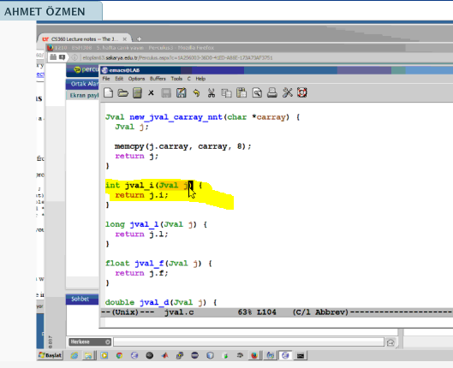
Yukarda 2 satır 2. Kelimeyi bulan programı yazınız.
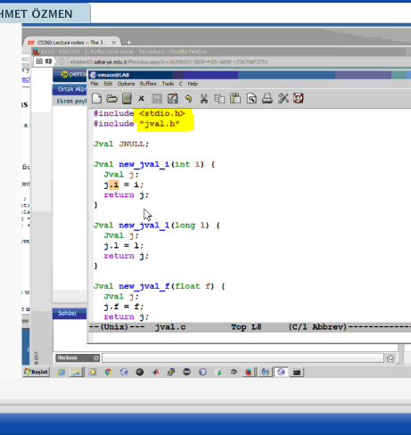
C de yazılmış hali solda makine diline çevrilmiş hali
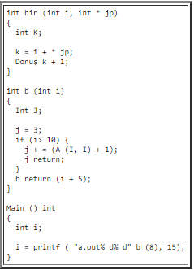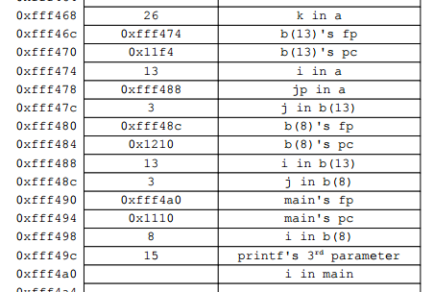

CS360 Lab #5 -- Assembler
- James S. Plank
- CS360

This is not a lab that you hand in. Instead, its goal is to help you reinforce the lecture notes on assembler, and to study for the exam. For that reason, I have included the answers with the lab. It is completely fair game for you to consult the TA's to help you with this material.
Additional study material:
- Question 1 from the 2011 Midterm Exam.
- Questions 3 and 4 from the 2004 Midterm Exam.
- Question 1 from the 2003 Midterm Exam. Maybe I should solicit money from the students to prevent me from asking a question like this again...

Do not "optimize" the assembler. Give me the simple yet inefficient assembler that the compiler would return.

Question 1
Derive the assembler for the following procedure.
int b(int j, int k)
{
int i;

i = j;
while (i > 0) {
j = (i * j) + (k * 3);
i--;
}
return j;
}
The answer is here.

Çözümü:
b:
push #4 / Allocate i
st %r2 -> [sp]-- / Spill r2 since you'll use it
ld [fp+12] -> %r0 / i = j
st %r0 -> [fp]
l1:
ld [fp] -> %r0 / while (i > 0)
cmp %r0, %g0
ble l2
ld [fp] -> %r0 / j = (i*j) + (k*3)
ld [fp+12] -> %r1
mul %r0, %r1 -> %r0
ld [fp+16] -> %r1
mov #3 -> %r2
mul %r1, %r2 -> %r1
add %r0, %r1 -> %r0
st %r0 -> [fp+12]
ld [fp] -> %r0 / i--
add %r0, %gm1 -> %r0
st %r0 -> [fp]
b l1
l2:
ld ++[sp] -> %r2 / Unspill r2
ld [fp+12] -> %r0 / return j
ret

Question 2
Derive the assembler for the following procedure. You may assume that NULL is equal to zero.
int f2(int *x)
{
int j;

if (x == NULL) return 37;

j = *x * 2;
return j;
}
The answer is here.

Çözümü:

f2:
push #4 / Allocate j
ld [fp+12] -> %r0
cmp %r0, %g0 / if (x == NULL)
bne l1
mov #37 -> %r0 / return 37
ret
l1:
ld [fp+12] -> %r0 / j = *x * 2
ld [r0] -> %r0
mov #2 -> %r1
mul %r0, %r1 -> %r0
st %r0 -> [fp]
ld [fp] -> %r0 / return j
ret

Question 3
Derive the assembler for the following program. In terms of grading, this would be worth three times Question 1 or Question 2.
int c(int i, int j)
{
if (i <= 0) return j+1;

return a(j, i-3)+1;
}

int a(int i, int j)
{
if (j <= 0) return i+1;
return c(i-1, j)+c(i-1, j-1);
}

main(int argc, char **argv)
{
int i;

if (argc != 3) { exit(1); }
i = a(atoi(argv[1]), atoi(argv[2]));
}
The answer is here.

Çözümü:

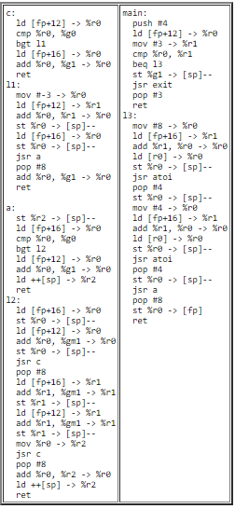

Question 4
Below is a snapshot of the stack when the program in Question 3 is executing. As in the "fact" example in Assembler Lecture #3, label each byte of the stack, and show where we are in the execution of the program (don't just label the PC -- show where we are in the call stack). You may assume that main starts at label 0x10a0, a starts at label 0x1040, and c starts at label 0x1000. Here's the Open Office of the picture if you want: q3-unlabeled.odg.
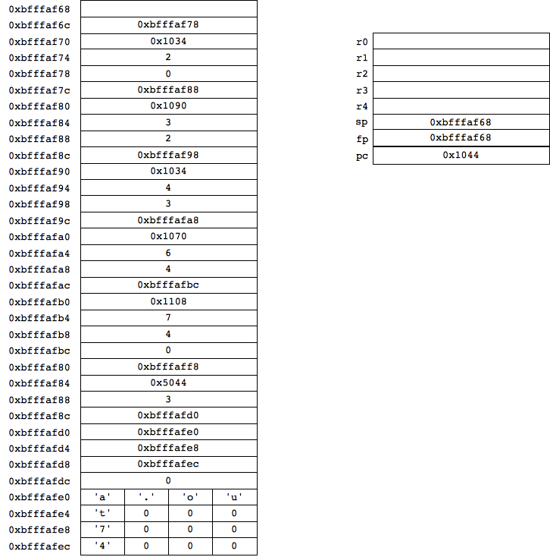
The answer is here.

